- Write a simple class with properties and methods and access the members by creating objects of the class.
class Bikes;
string brand;
int speed;
int distance;

function new(string m_brand,int m_speed,int m_distance);
brand = m_brand;
speed = m_speed;
distance = m_distance;
endfunction
task update(int m_speed, int m_distance);
speed = m_speed;
distance = m_distance;
endtask
function void print();
$display("brand: %s |speed: %0dkm/h|distance: %0d km", brand, speed, distance);
endfunction
endclass

module class_Bikes;
Bikes bk;
initial begin
bk = new("Yamaha",75,115);
$display("Intitial Details:");
bk.print();
bk.update(85,145);
$display("update details:");
bk.print();
end
endmodule

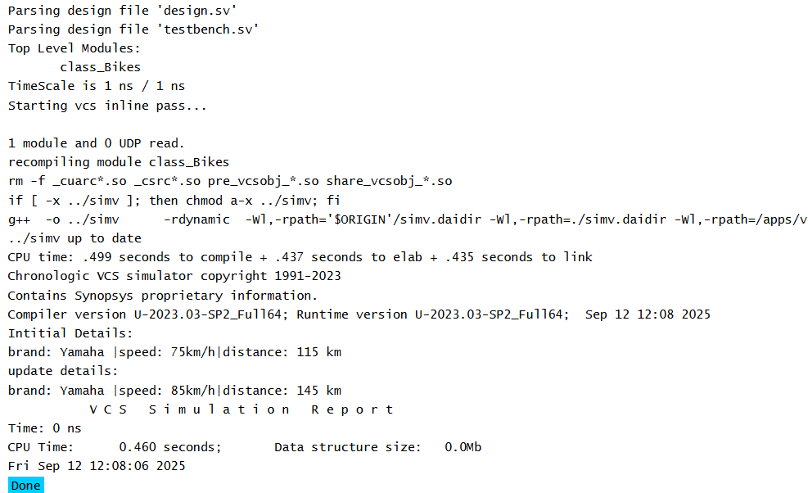

2.Write a class to demonstrate polymorphism with parent and child class
class bikes;
virtual function void bike_brand();
$display("Bike Brand");
endfunction
virtual task features();
$display("model && engine_capacity");
endtask
endclass
class Royal_Enfield extends bikes;
function void bike_brand();
$display("Brand --> Royal Enfield");
endfunction
task features();
$display("model = Bullet 350\nEngine_Capacity = 349cc");
endtask
endclass
class Yamaha extends bikes;
function void bike_brand();
$display("Brand --> Yamaha");
endfunction
task features();
$display("model = FZ\nEngine_Capacity = 149cc");
endtask
endclass
class scooter extends Yamaha;
function void bike_brand();
$display("Brand --> Yamaha (scooter)");
endfunction
task features();
$display("model = Fascino 125 FI\nEngine_Capacity = 125cc");
endtask
endclass
module class_example;
bikes bike;
Royal_Enfield R1;
Yamaha Y1;
scooter S1;
initial begin
R1 = new();
Y1 = new();
S1 = new();
bike = R1;
bike.bike_brand();
bike.features();
bike = Y1;
bike.bike_brand();
bike.features();
bike = S1;
bike.bike_brand();
bike.features();
end
endmodule
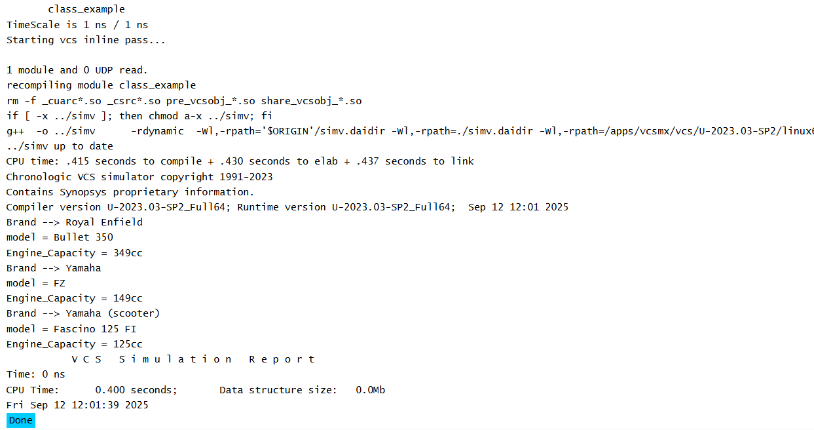

3.Write a class to demonstrate this keyword, super keyword, access qualifiers(local and protected)

class Animal;
protected string species;

function new(string species);
this.species = species;
endfunction

virtual function void printspecies();
$display("Animal species: %s", species);
endfunction
endclass

class Tiger extends Animal;

string name;

function new(string species, string name);
super.new(species);
this.name=name;
endfunction

function void printDetails();
super.printspecies();
$display("tiger name: %s", this.name);
endfunction
endclass

module test_this_super;
initial begin
Tiger tiger = new("Caspian tiger", "Brownie");
tiger.printDetails();
end
endmodule

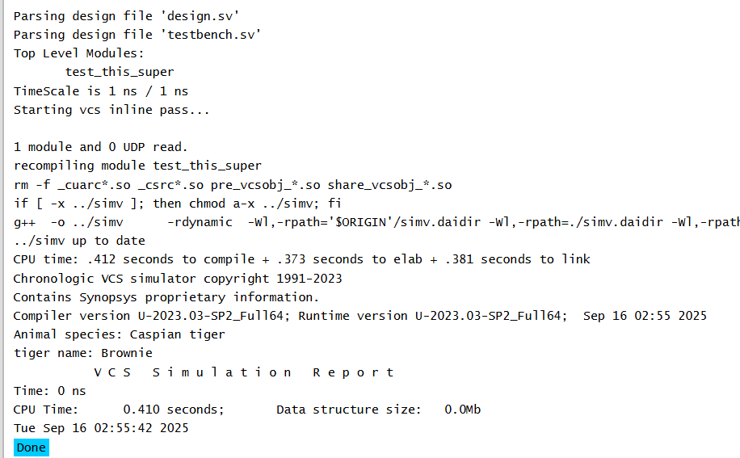

4.Write a class to demonstrate shallow copy

class address;
string city;
int pin;
function new(string c = "chennai",int p=600062);
city = c;
pin = p;
endfunction
endclass

class person;
string name;
address addr;
function new(string n = "vicky", string c = "Chennai", int p = 600062);
name = n;
addr = new(c,p);
endfunction

function void display();
$display("Name = %s, City = %s, Pin = %0d", name, addr.city, addr.pin);
endfunction
endclass

module shallow_copy_test;
initial begin
person p1, p2;
p1=new("vicky","vellore",635601);
$display("__before shallow copy__");
p1.display();
p2 = new p1;
$display("__After shallow copy__");
p2.display();

p2.name = "Arshath";
p2.addr.city = "Theni";
p2.addr.pin = 600059;
p2=new("Arshad","theni",60059);

$display("__After modification__");
$display("p1 info:");
p1.display();
$display("p2 info:");
p2.display();
end
endmodule

